**Online Python Shell**

<https://www.python.org/shell/>

Steps to use the online python shell

1. Go to the link <https://www.python.org/shell/>

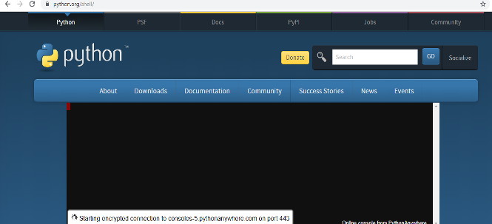

It might take some time for the shell to be loaded. Please wait 1-2 minutes for the shell to load completely.

1. Once it loads, you can use the shell to write your code

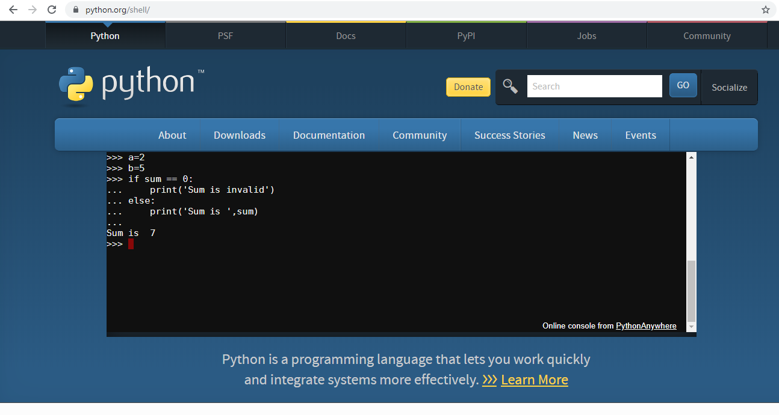

 Alternately, you can use other available online compilers too.

The links of some of these compilers are given below.

**Online Python Compiler Links**

1. <https://www.onlinegdb.com/online_python_compiler>

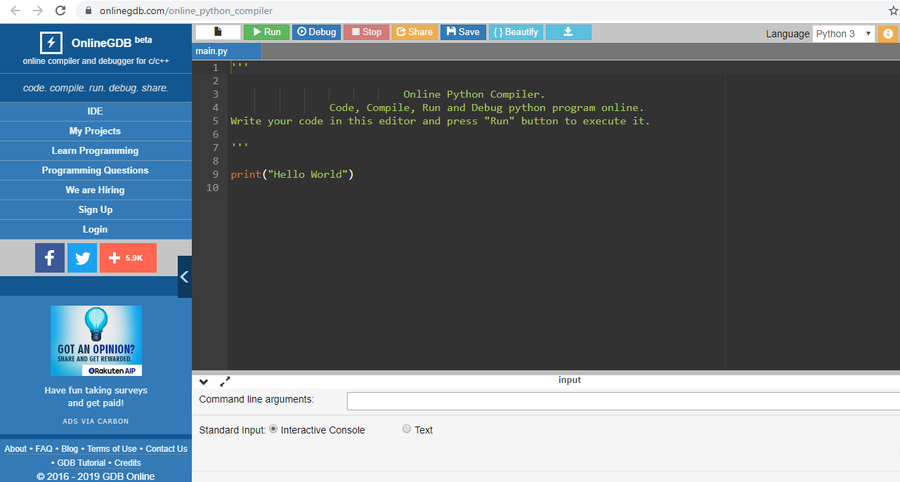

           2.  [tutorialspoint.com/execute_python_online.php](https://www.tutorialspoint.com/execute_python_online.php)

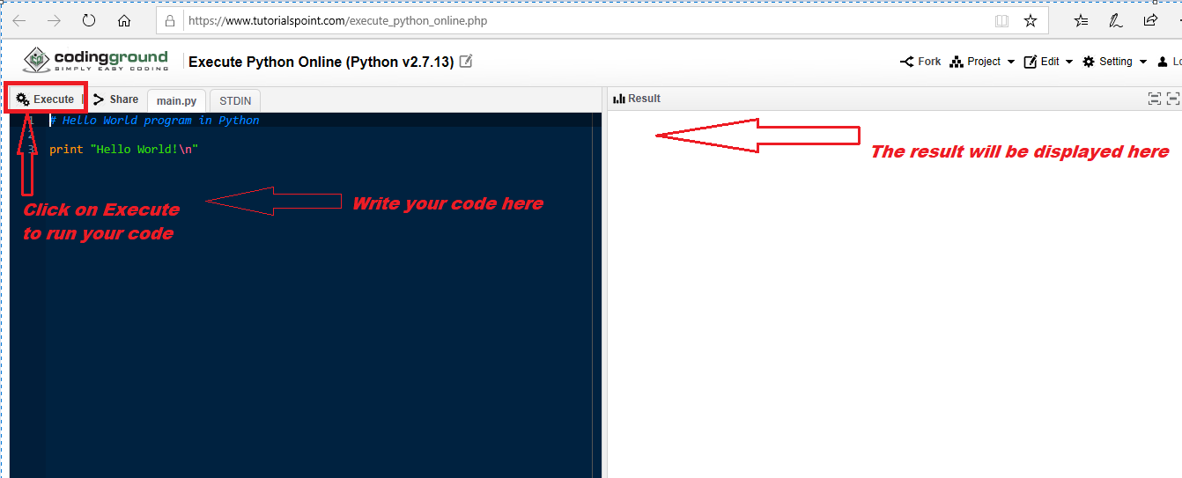

1. <https://repl.it/languages/python3>

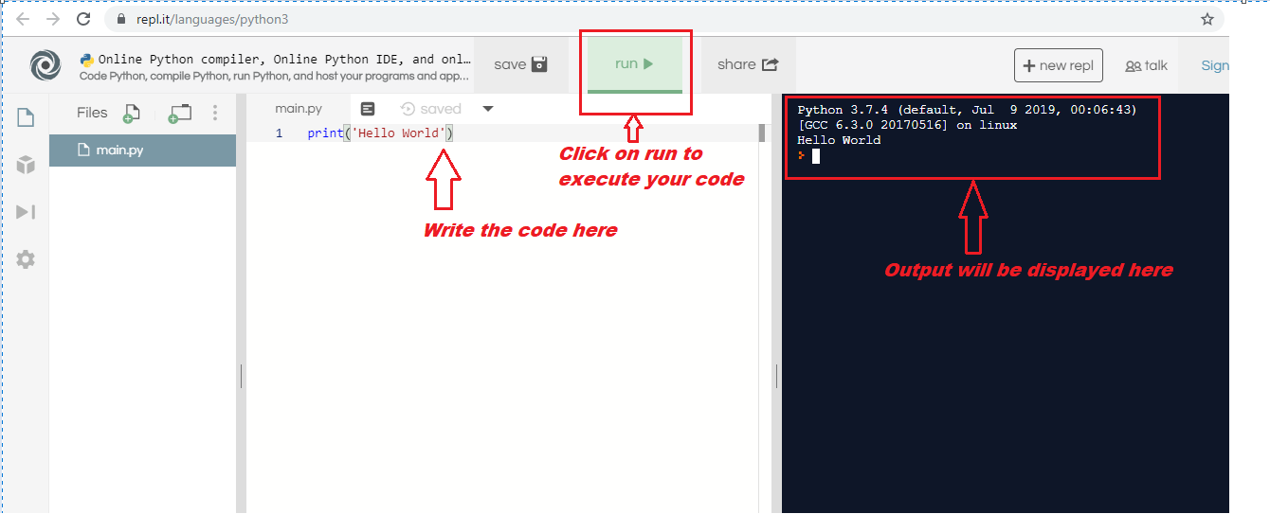

1. Write a python program to print the following lines in the given format

"Hello, Thank you" Adam said.

"You're very welcome, Have a good day!" Ron responded.

2. Write a Python program to accept a number and check if its odd or even. Print appropriate messages.

3. Write a Python program to print the multiplication table of a number. The number is to taken as user input.

4. Write a Python program to accept two strings as input and check if they are identical copy of each other or if the second string is a substring of the first string. If they are identical, print "Both the strings are same". If the 2nd string is substring of the 1st string, print " is a substring of . Please note that the value for String1 and String2 should be printed in place of the holders.

5. Create a menu driven Python program to operate on a list of numbers which is provided by the user. The different operations to be provided are :

         a. Add all numbers

         b. Find the highest number

         c. Find the average of all the numbers

         d. Find the numbered with highest frequency in the list.

6.  A school has many students studying in different standards. Each student has a roll number, name, marks in 4 subjects and standard. The school wants a system that can calculate his grade and promote him/her if his grade is greater than 'F'. The criteria for grade calculation is:

i. If percentage >=80,  grade  is  'A'  
ii. if  60<=percentage<80, grade  is 'B'  
iii. if 40<=percentage<60, grade is 'C'  
iv. percentage<40, grade is 'F'

7. A bookshop has many books belonging to different categories like horror, romance, non-fiction etc. Each book has a name, ID,price, category and the author name. The bookshop wants an automated system with which it can get  the price of a particular book.   
Also, the bookshop wants the system to update the price of a given category of books if needed by a given price. Implement the scenario using OOP in Python.